要点: properties是map的子类
无论是保存还是读取,都要先创建properties对象
保存:
- 依据路径path先判断文件是否存在,不存在就新建一个.
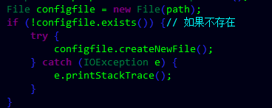
- 对File文件输送数据,建立起程序对这个文件的输出流,输出数据到这个文件
Store()方法要在写完数据后调用,以保证数据能保存.
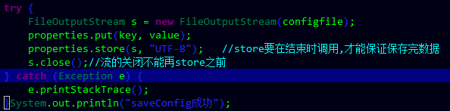
读取:
- 依据路径path找到文件,如果存在,读取数据.建立文件与程序之间的数据流,从文件读入数据到程序.
load()方法要在正式的获取数据之前调用.以保证能拿到数据.
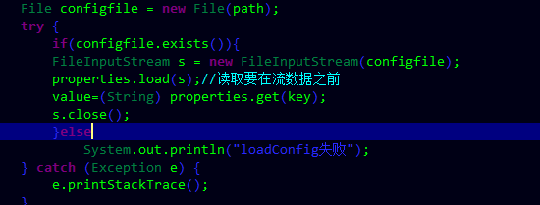

示例:
static String path = "C:\\Users\\Administrator\\Desktop\\经典文档\\a.txt";
public static void main(String[] args) {
System.out.println(""+saveConfig(path,"www","123"));
String a=loadConfig(path,"www");
System.out.println(a);
System.out.println(""+saveConfig(path,"www","321"));
String b=loadConfig(path,"www");
System.out.println(b);
}
//读取某文件中的键值对
public static String loadConfig(String path,String key) {
String value = null;
Properties properties = new Properties();
File configfile = new File(path);
try {
if(configfile.exists()){
FileInputStream s = new FileInputStream(configfile);
properties.load(s);//读取要在流数据之前
value=(String) properties.get(key);
s.close();
}else
System.out.println("loadConfig失败");
} catch (Exception e) {
e.printStackTrace();
}
return value;
}
//向某文件中保存键值对
public static String saveConfig(String path,String key, String value) {
Properties properties = new Properties();
File configfile = new File(path);
if (!configfile.exists()) {// 如果不存在
try {
configfile.createNewFile();
} catch (IOException e) {
e.printStackTrace();
}
}
try {
FileOutputStream s = new FileOutputStream(configfile);
properties.put(key, value);
properties.store(s, "UTF-8"); //store要在结束时调用,才能保证保存完数据
s.close();//流的关闭不能再store之前
} catch (Exception e) {
e.printStackTrace();
}System.out.println("saveConfig成功");
return value;
}
结果:
控制台:
saveConfig成功
123
123
saveConfig成功
321
321

文件:
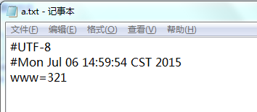
但是,上面这个示例每次只能写一个,新写入的键值对会覆盖掉旧的.这是因为properties不是同一个.
示例2:
public static void main(String[] args) {
Properties properties = new Properties();
properties.put("123", "www");
properties.put("234", "qqq");
properties.put("345", "sss");
saveAll(properties);
//遍历这个键值对集合
Map map=returnAll(properties);
Set<Entry<String,String>> entrySet = map.entrySet();
Iterator<Entry<String,String>> it = entrySet.iterator();
while(it.hasNext()){
Entry entrt=it.next();
String key = (String) entrt.getKey();
String value = (String) entrt.getValue();
System.out.println(key+"="+value);
}

}

public static void saveFile(Properties properties,String path){
File file=new File(path);
if(!file.exists()){
try {
file.createNewFile();
} catch (IOException e) {
e.printStackTrace();
}
}
try {
FileOutputStream s = new FileOutputStream(file);
properties.store(s, "UTF-8");
} catch (Exception e) {
// TODO Auto-generated catch block
e.printStackTrace();
}
}
public static Object loadFile(Properties properties,String path){
File file=new File(path);
if(file.exists()){
try {
FileInputStream s = new FileInputStream(file);
properties.load(s);
return properties;
} catch (Exception e) {
// TODO Auto-generated catch block
e.printStackTrace();
}
}
return null;
}

public static void saveAll(Properties properties){
String path = "C:\\Users\\Administrator\\Desktop\\经典文档\\b.txt";
saveFile(properties,path);

}
public static Properties returnAll(Properties properties){
String path = "C:\\Users\\Administrator\\Desktop\\经典文档\\b.txt";
return (Properties) loadFile(properties, path);
}
结果:
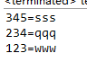
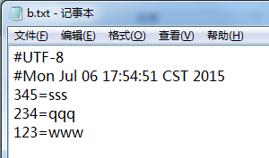
补充:
Map键值对的遍历:
//最常规的一种遍历方法，最常规就是最常用的，虽然不复杂，但很重要，这是我们最熟悉的，就不多说了！！
public static void work(Map<String, Student> map) {
Collection<Student> c = map.values();
Iterator it = c.iterator();
for (; it.hasNext();) {
System.out.println(it.next());
}
}
//利用keyset进行遍历，它的优点在于可以根据你所想要的key值得到你想要的 values，更具灵活性！！
public static void workByKeySet(Map<String, Student> map) {
Set<String> key = map.keySet();
for (Iterator it = key.iterator(); it.hasNext();) {
String s = (String) it.next();
System.out.println(map.get(s));
}
}
//比较复杂的一种遍历在这里，呵呵~~他很暴力哦，它的灵活性太强了，想得到什么就能得到什么~~
public static void workByEntry(Map<String, Student> map) {
Set<Map.Entry<String, Student>> set = map.entrySet();
for (Iterator<Map.Entry<String, Student>> it = set.iterator(); it.hasNext();) {
Map.Entry<String, Student> entry = (Map.Entry<String, Student>) it.next();
System.out.println(entry.getKey() + "--->" + entry.getValue());
}
}
}
或者
Set<Entry<String,String>> entrySet = map.entrySet();
Iterator<Entry<String,String>> it = entrySet.iterator();
while(it.hasNext()){
Entry entrt=it.next();
String key = (String) entrt.getKey();
String value = (String) entrt.getValue();
System.out.println(key+"="+value);
}
java.util.NoSuchElementException错误:
interator出现了越界.一般是it.next();时的错

